This is a document presenting evaluation of the interactive design of the application “DADWORK”. The report mentions the MARS evaluation method and results, highlights of “DADWORK” as well as its potential improving aspects. The report ends up by mentioning how well MARS framework works in this evaluation.

Evaluation of application “DADWORK”

--pros, cons & improvements

Sam Yan, 886958

student of e-health

University of Melbourne

## Executive Summary

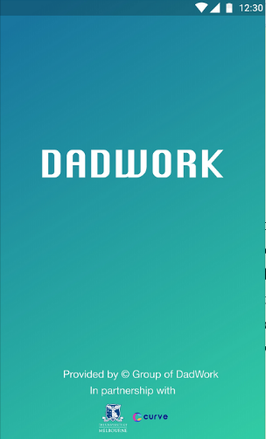 “DADWORK” is designed as a mobile phone application aiming at supporting pregnant consultation services booking, pregnant knowledge support and pregnant information sharing. An evaluation has been conducted following the Mobile Application Rating Scale (MARS) framework to the interactive design (IdX) of this application (Stoyanov et al., 2015). Each question has been answered, and the mean scores of the questions have been calculated for each section from A-D. The app quality mean score is than calculated by taking the average value of the mean value from each sections from A-D. The app was also measured by its subjective quality and perceived impacts.

According to the evaluation, “DADWORK” performs higher than average in application quality and it performs well in functionality, while it might need to improve in its user-engagement and quality of information. As for other aspects mentioned by MARS, it might to consider improving its subjective qualities and appears to be more appealing to users. As a second point, the application still has spaces for improving its perceived impacts. Because there are five tags for “DADWORK”, they are “home”, “checklist”, “calendar”, “support” and “account”, the report will comment on each tag on its highlights and aspects that needs improvement correspondingly.

## Highlights of the design

In general, “DADDY WORK” has sufficient functions provided to its intended user groups, and it provides functions to set personal profile so that users are feeling engaged with the application to some extends. Leading users to specific appointments provides another customized function, which improves the usability of the application. Furthermore, it gathers user feedbacks of the application, providing a good way to improve this application to further meet user requirements.

### C:\Users\Sam_Yan\AppData\Local\Temp\1558750406(1).pngC:\Users\Sam_Yan\AppData\Local\Temp\1558750373(1).pngTab: Home

* Personalized welcome information provides customized feelings to users.
* The navigations to other tabs on the “home” page is clear and works functionally well.

### C:\Users\Sam_Yan\AppData\Local\Temp\1558750748(1).pngTab: Checklist

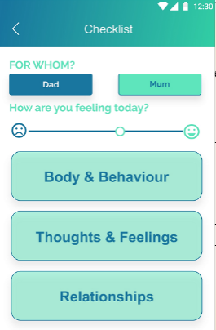

* The settings are able to customize users by user group.
* The slide bar and buttons on this page is easy to understand and the navigation fits the logic.

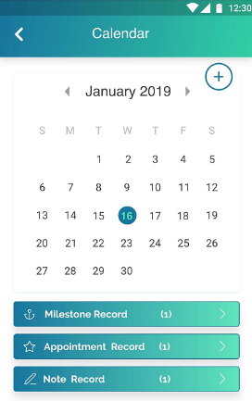

### Tab: Calendar

* The fonts are proper and information on each button and the related pages is generally easy to read and easy to understand.

### C:\Users\Sam_Yan\AppData\Local\Temp\1558751199(1).pngTab: Support

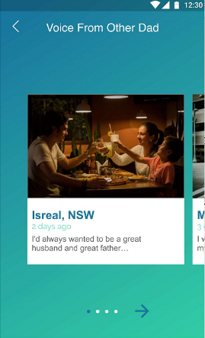

* The overall layout of this page is clear, with buttons having clear meanings and nice fonts.
* The page “voice from other dad” leads to a community of users, which makes users feel engaged and appealing.

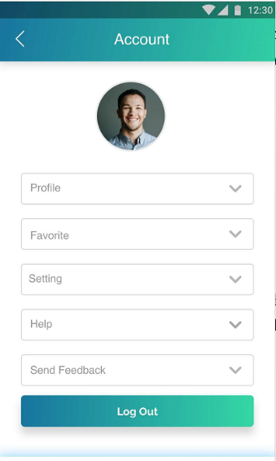

### Tab: Account

* The fonts of the drop-down lists on this page are very clear and easily understandable.
* The “send feedback” page provides a mechanism to gather users’ opinions, providing the application a future chance to improve, which is a good design.

## Potential improvements of the design

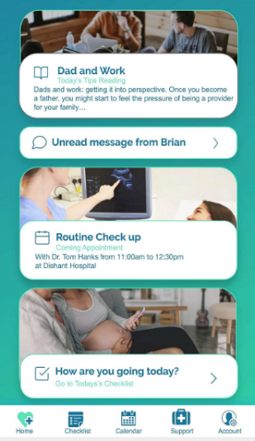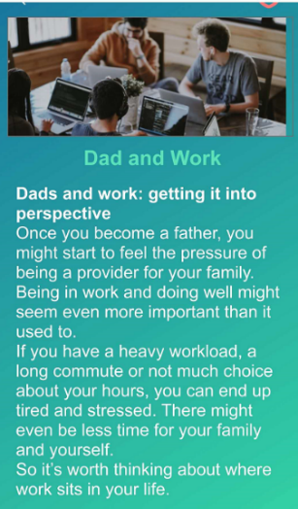The overall looking could be more appealing, rather than using simply a blue-green background. User groups of this application does not seem to be clear – some pages are only designed for “dads” while some pages have information about both “mums” and “dads”. The designers need to work on targeting at a more specific user. The overall impact of this application might not be significant – many apps on the market already have these functions such as pregnancy tracking and general practitioner appointments. The designers need to think of a unique way that their app stands out compared to other apps.

### Tab: Home

* The home page is squeezed with a long list of information and this design might be overwhelmed to users.
* Fonts of those “squeezed” information is so small that the information presented in those tags is difficult to read.

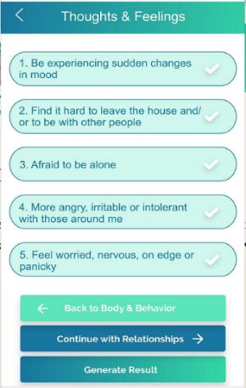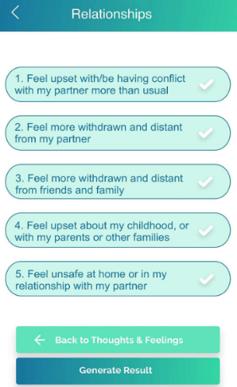

### Tab: Checklist

* There are 15 questions before generating an individual report of the status, which might be too much and letting the depressed dad feeling overwhelmed.

### C:\Users\Sam_Yan\AppData\Local\Temp\1558760932(1).pngTab: Calendar

* 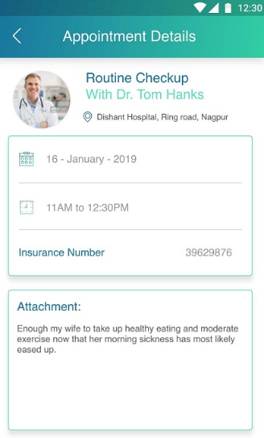The intention of the calendar is not clear: it can only be used to notify users, rather than adding appointments. To add an appointment, users have to click ‘+’ and manually input date information, which might not be a good design.
* The meanings of “milestone record” and “note record” are not very understandable.

### C:\Users\Sam_Yan\AppData\Local\Temp\1558761407(1).pngC:\Users\Sam_Yan\AppData\Local\Temp\1558761449(1).pngTab: Support

* Each page under “tips for you” provides either too little information that is actually useless (e.g. under “relations”) or it is overwhelming (e.g. under “depression”).
* Nicer layouts that those tip-information could be designed, to better deliver information in a more appealing and engaging mean.

### C:\Users\Sam_Yan\AppData\Local\Temp\1558761757(1).pngC:\Users\Sam_Yan\AppData\Local\Temp\1558761673(1).pngTab: Account

* The meaning of the “help” button seems confusing, the designers did not indicate whether it is a button for teaching how can users use this application, or whether users use it when meeting specific problems in pregnancy so that they need help.

## How well is MARS

This report uses the “Strengths-Weaknesses-Opportunities-Threats” (SWOT) analysis to analyze how well MARS works in evaluating the intended IdX, and will mention each aspect of MARS correspondingly.

|  |  |
| --- | --- |
| Strengths | * MARS provides a very systematic and clearly described approach of evaluating app quality, and the evaluation steps are clear and operable, making its evaluations of app quality convincing. * It considered many aspects apart from only measuring functionality of an application, which provided a thorough view of how the app could be improved in the future. * The test is easy-to-learn and easy-to-implement, making it generalizable. |
| Weaknesses | * It assumes all the parts of app-quality are of the same weight. However, for those apps stressing patient-centric or user-centric context or content (Andargoli, Scheepers, Rajendran, & Sohal, 2017), engagement might be more important than functionality and aesthetics, while simply using MARS cannot stress this issue. * For one evaluation from one person, such as in this case, the result might be biased from multiple evaluators evaluating the same app, which means that depends on how the app is evaluated, the results could be biased or different. * The evaluation might not be “customized” for certain apps or situations. For example, in this evaluation, many questions are with answers “N/A”, which might not be a very good design. |
| Opportunities | * When testers or evaluators of an app is sufficient, by applying this evaluation, one can get a good view about overall qualities of the app. * The developing team of an app can use this scale by themselves before they finish to let others test. |
| Threats | * For the four app quality dimensions, one might set different weight values based on the different goals of the app. For example, if the app wants to have more engagement with patients, then the weights for questions in the engagement could weight higher scores. * To avoid the bias introduced by having too little evaluation results, one might invite more testers or evaluators. However, this may potentially increase the cost on the test. * For those “N/A” questions, one might consider replace another question which fits the purpose of the app, however, this replacement might be subjective and not large-scale operable, and could work as another reason that biases are introduced. |

## Appendix

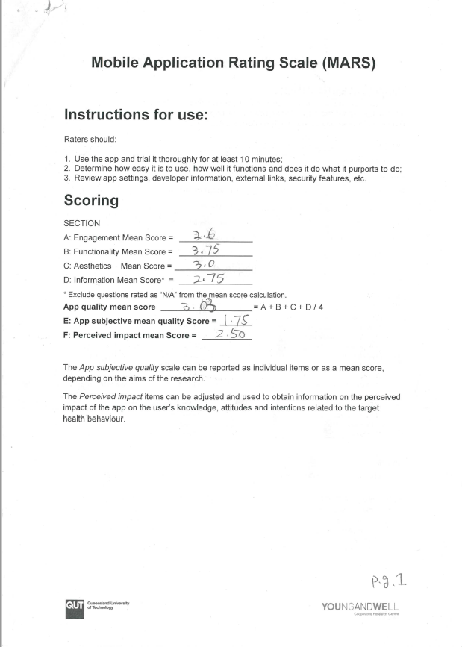

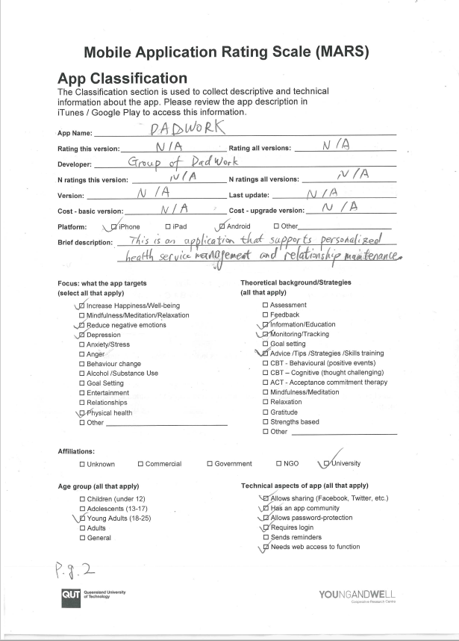

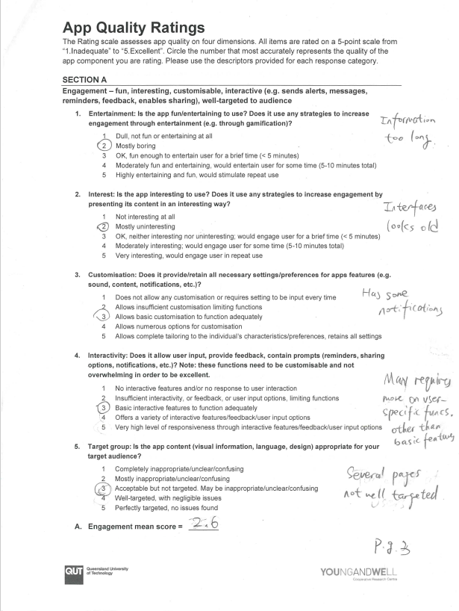

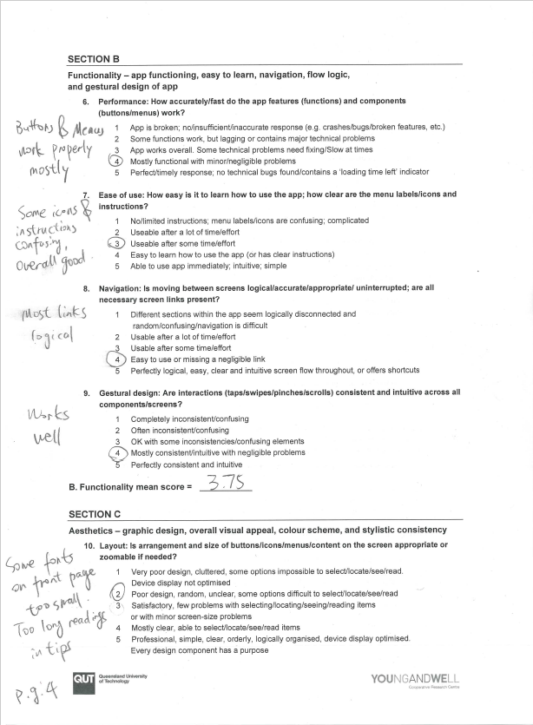

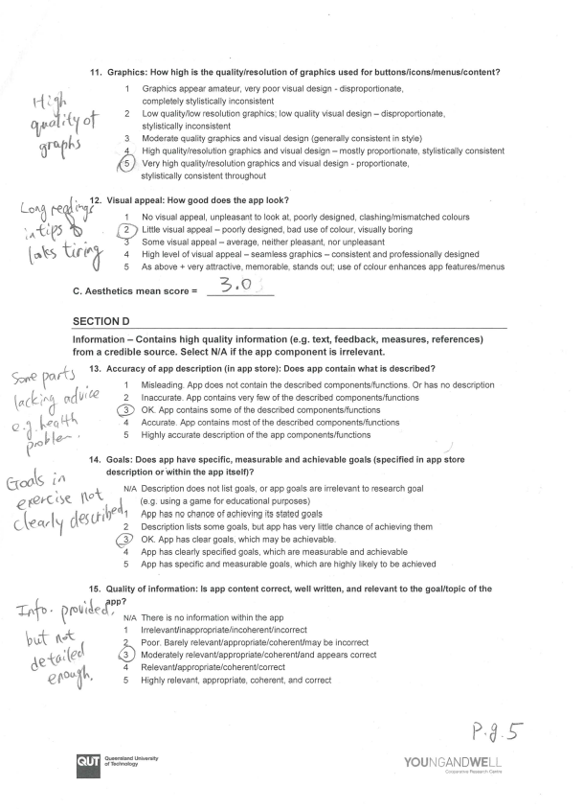

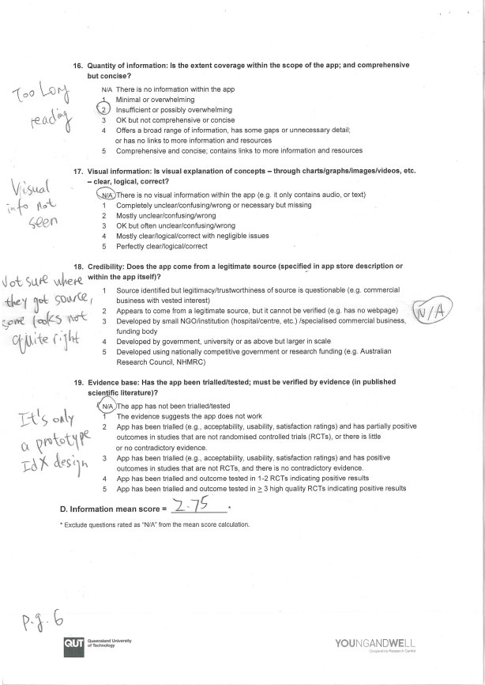

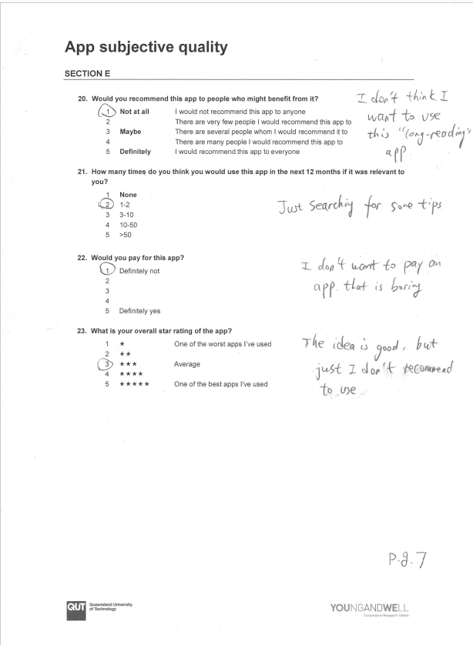

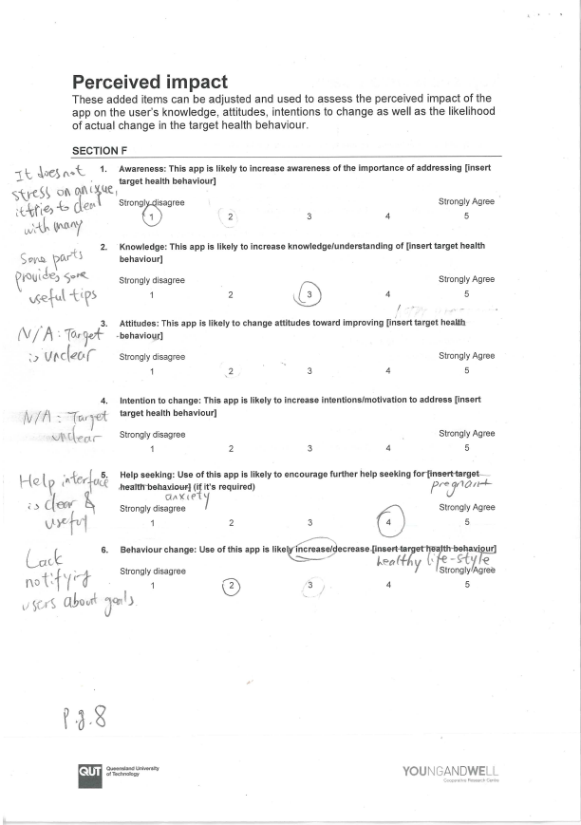

(word count = 995)

## References

Andargoli, A. E., Scheepers, H., Rajendran, D., & Sohal, A. (2017). Health information systems evaluation frameworks: A systematic review. *International Journal of Medical Informatics*, 195. https://doi.org/10.1016/j.ijmedinf.2016.10.008

Stoyanov, S. R., Hides, L., Kavanagh, D. J., Zelenko, O., Tjondronegoro, D., & Mani, M. (2015). Mobile App Rating Scale: A New Tool for Assessing the Quality of Health Mobile Apps. *JMIR MHEALTH AND UHEALTH*, *3*(1). https://doi.org/10.2196/mhealth.3422

The screenshots in this document all comes from the IdX of the app “DADWORK”